Ripon Canal Walk
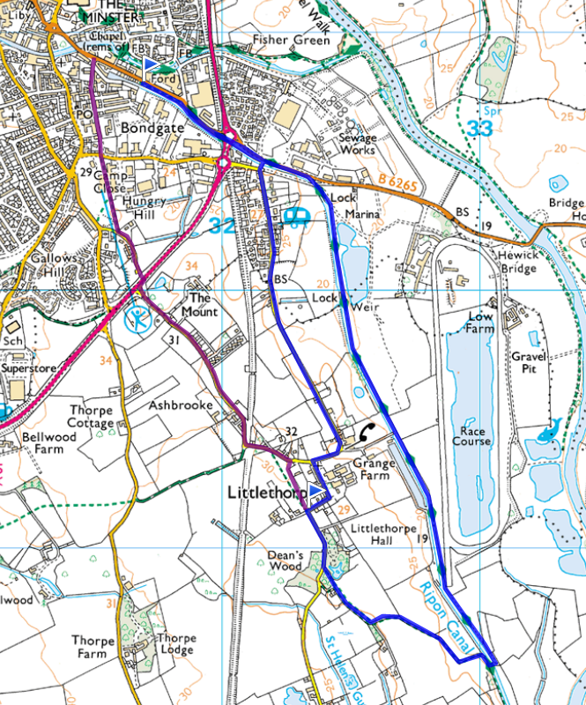
Follow the canal towpath till it crosses the canal, then return through Littlethorpe. Purple route crosses the main road, so take care – but it is slightly shorter.
Slower walkers can cross the bridge by the marina at Grange Farm, I think.
Please report back with photos, so I can write it up properly.
http://www.getamap.ordnancesurveyleisure.co.uk/?key=6UxzlWfqavNsxRvwuee3SA2



